**Internet Programming**

**Question 1 - MVC**

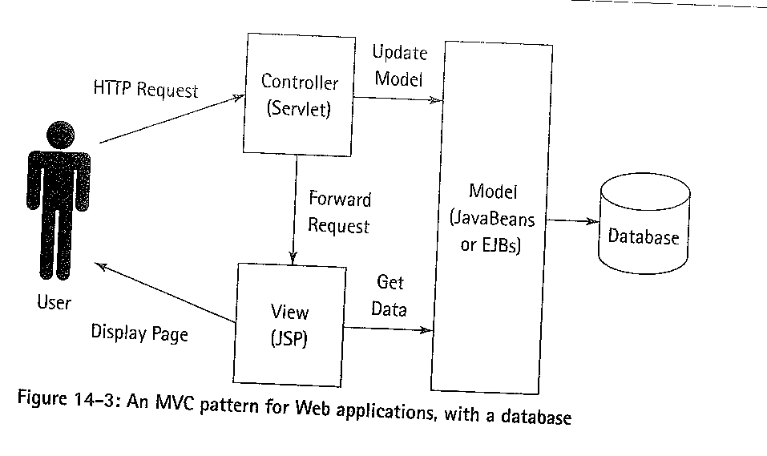

Bean is the model, JSP is the view and Servlet is the controller.

**1(b) Java Technologies Used to Implement MVC**

**Java Beans – Model -** Fully reusable components - access the database and server side components

**Java Servlets – Controller -** Servlets are used for load balancing

**Java Servlet Pages – View –** Rendering the html

**1(c) 2 roles of beans**

**Entity Beans** - setup a database connection or do calculations

**Session Beans** - Holds information required by the browser once control has been passed to the view.

**1(d) How is a URL mapped onto a servlet / Example**

* Servlet Mapping
* Servlet Name
* Url Pattern

<**servlet-mapping**>

<**servlet-name**>HtmlFilter</servlet-name>

<**url-pattern**>/HtmlFilter</url-pattern>

</**servlet-mapping**>

**1(e) Pass Control from the browser to the view**

Redirect - response.sendRedirect("/jabadot/");

* User clicks in Browser and creates a HTTP Request
* Http request is received by the controller
* Controller creates a bean ( if needed ) and passes bean to view as attribute of HTTP response
* Controller is complete and sends redirect to view
* View is rendered ( using bean data if requested )

**Question 2 - Database / Cassandra**

**2(a) Roles of Prepared Statements and Stored Procedures – Security**

**Prepared Statements**

|  |  |
| --- | --- |
| * **SQL Injection**- you don't need to escape anything, you just need to bind the parameters. * Stored procedures are a sequence of instructions store sequences of queries frequently applied to your model |  |
| **Stored Procedures**   * **Grant Permissions** directly to underlying tables – READ / Insert / Update * Obstructed - the real-underlying schema information can be encapsulated/hidden away (SPs can be encrypted too) |  |

* Script Attacks
* Database Bridge – Protecting root access
* Application Security – Protecting CRUD – Expose interface over tables

**2(B) Cassandra Database model**

Peer to Peer architecture

Writes in Cassandra

**2 ( c) Consistency levels in Cassandra**

**CAP Theorem**

* Consistency
* Availability
* Partional Avilibility

**Any** – Must succeed on any availably note

**One** – Must succeed on any node responsible for that row ( either Primary or replica)

**Quorum** – must succeed on a quorum of replica nodes ( replication factor /2 ) + 1

**Local quorum** – successful on a quorum of replica nodes in the same data centre

**Each quorum** – successful on a quorum of replica nodes in all data centers.

**All** – write must succeed on all replica nodes for a row key.

**2 ( D ) Advantages of a pool for relational database access**

Can refuse future requests to preserve performance

**Question 3 RESTful and AJAX**

**3 (A) Roles of HTTP commands in the implementation of a restful**

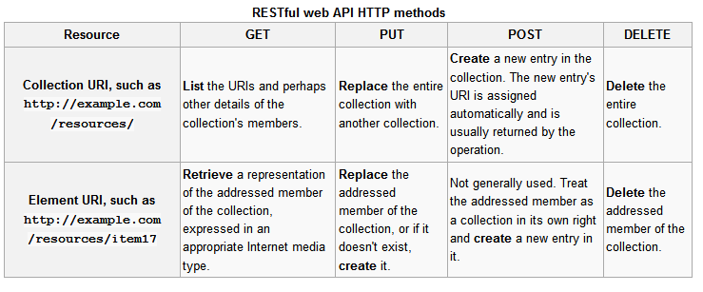

**Get**

* Retrieve all resources in a collection
* Retrieve a single resource

**Put**

* Update a resource
* Update or create

**Post**

|  |  |
| --- | --- |
|  | * **Create a new resource in a collection** |

**Delete**

* delete a resource

**Question 3 (b) Ajax vs client / serve relationship**

Fat vs Thin Client

Asynchronous Javascript and XML

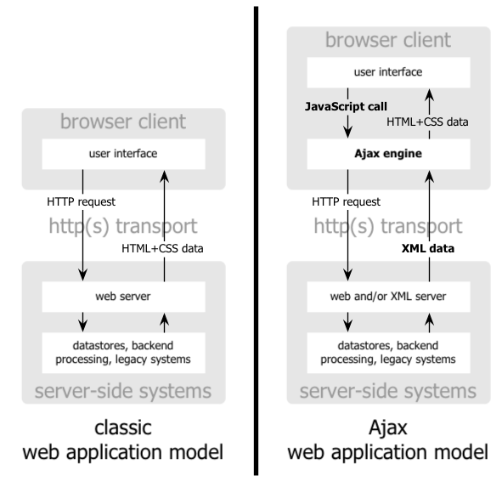

1. Create a HTTP request
2. Register a callback function to handle returned data
3. Make the request
4. Do something with the data

**Question 4 XML / RSS / JSON**

Really simple syndication

**Question 5 ROR, YARIA, Server Login**

**5 (A ) Wai-aria**

* Used for providing information about dynamic content.
* Provides web developers with additional important about semantics of web elements.
* E.g. Tags that can be included in HTML to increase accessibility. Down levelling – degrasing gracefully. Degradation .
* Web fonts have been made available to replace images. However it could be used to provide a textual alternative to screen readers.

**5 ( B ) Compare Java and RoR**

* RoR is MVC
* Java can use MVC
* Ror generates frame work and has reusable templates – DRY
* Java does not have any frame works or reusuable templates
* Both have a range of libraries but both are implemented differently
* Databases implemented differently. Ror handles bridge, Java manual

% ( C ) Logging mechanism

Detect